Кроссворд «Фрукты и ягоды»

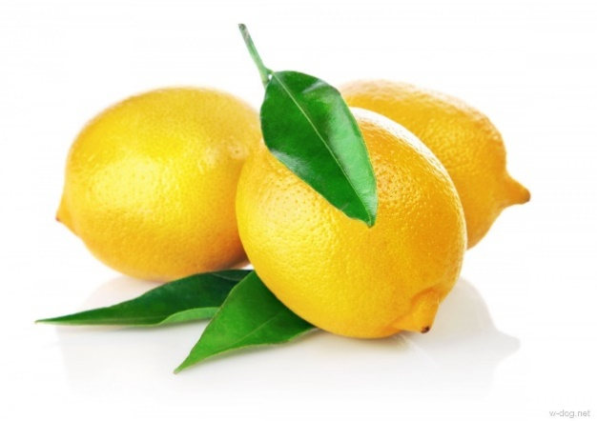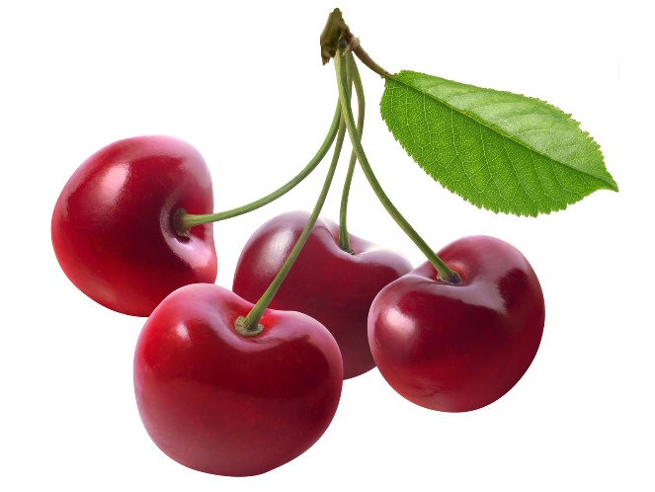1 2

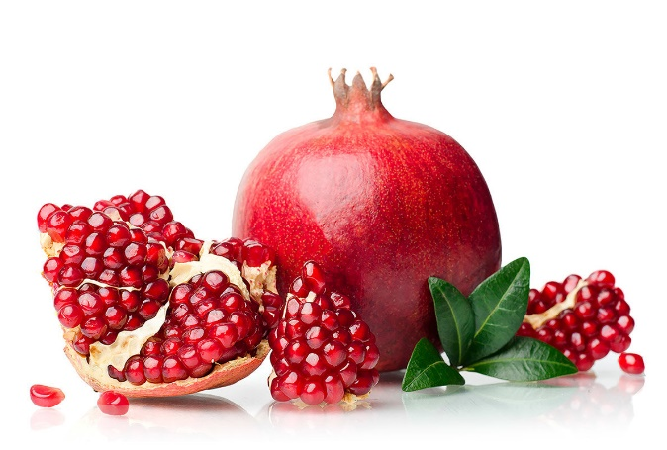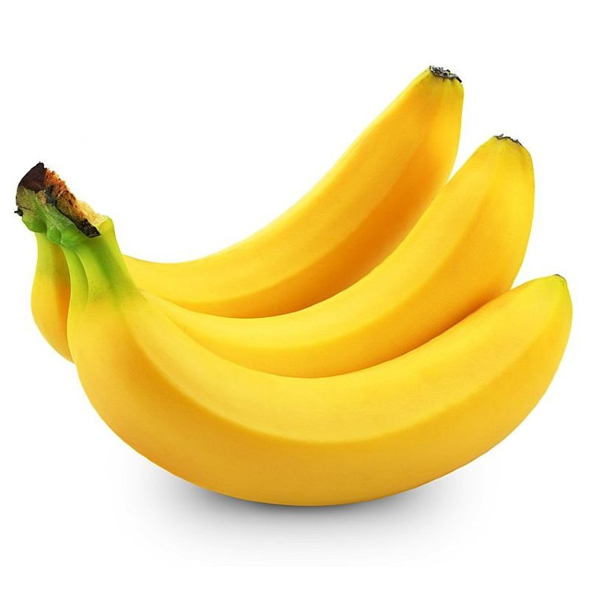

|  |  |  |  |  |  |  |  |  |  |  |  |
| --- | --- | --- | --- | --- | --- | --- | --- | --- | --- | --- | --- |
|  | | | | | | 1 |  |  |  |  |  |
|  | | | | | 2 |  |  |  |  |  |
|  | 3 |  |  |  |  |  |
|  | | | | 4 |  |  |  |  | | |
|  | | | | | | 5 |  |  |  |  |  |
| 6 |  |  |  |  |  |  |  |  | | | |
| 3 | | | 7 |  |  |  |  |  |  | | |
|  | | 8 |  |  |  |

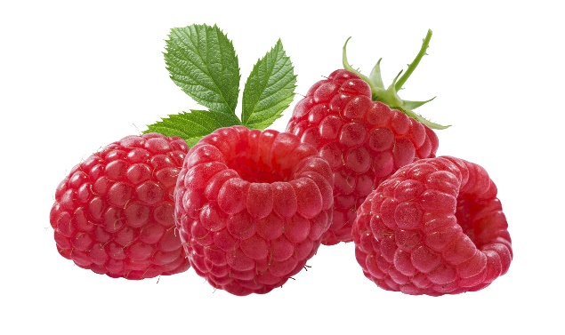 5 4

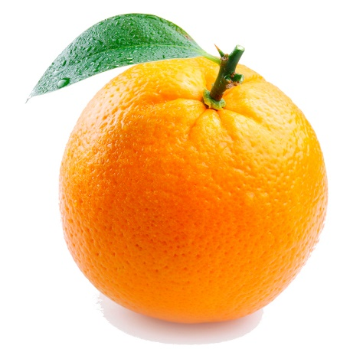

6

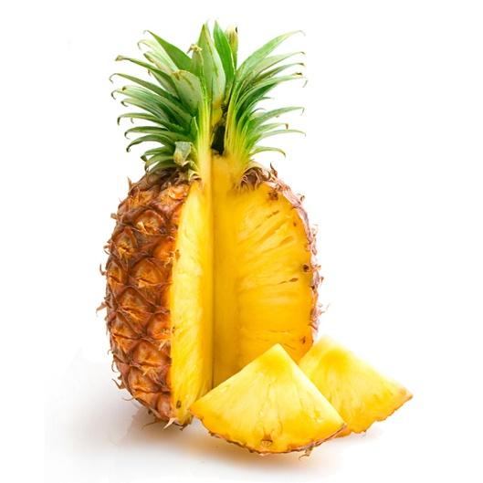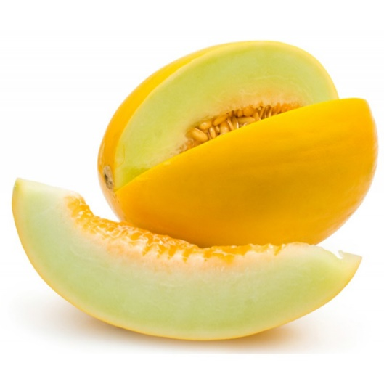

7 8

Ответы: 1. Вишня; 2. Лимон;

3. Гранат; 4. Банан; 5. Малина;

6. Апельсин; 7. Ананас; 8. Дыня.