|  |  |  |  |  |  |  |  |  |  |  |
| --- | --- | --- | --- | --- | --- | --- | --- | --- | --- | --- |
|  | **1** |  |  | **Н** |  |  |  |  |  |  |
|  | | **2** | **А** |  |  |  |  |  |
|  | | | | **3С** |  |  |  |  |  |  |
|  | | **4** |  | **Е** |  |  |  |  |  |  |
| **5** |  |  |  | **К** |  |  |  |  | | |
|  | | | **6** | **О** |  |  |  |
|  | | | | **7М** |  |  |  |  |  |  |
| 4 | | **8** |  | **Ы** |  | | | | | |
|  | | **9** |  | **Е** |  |  |  | | | |

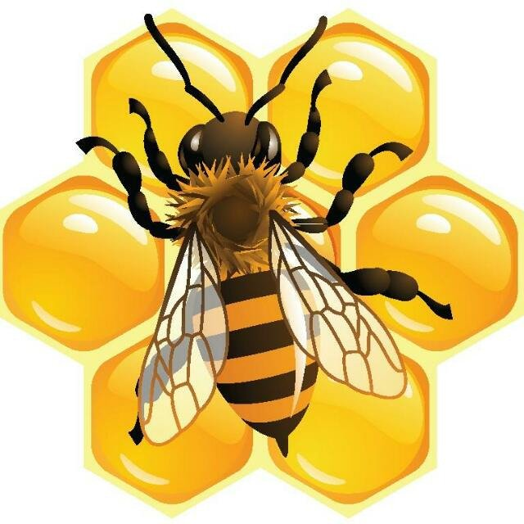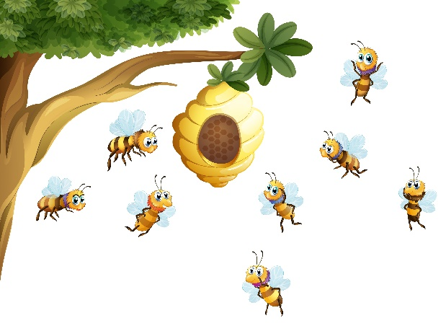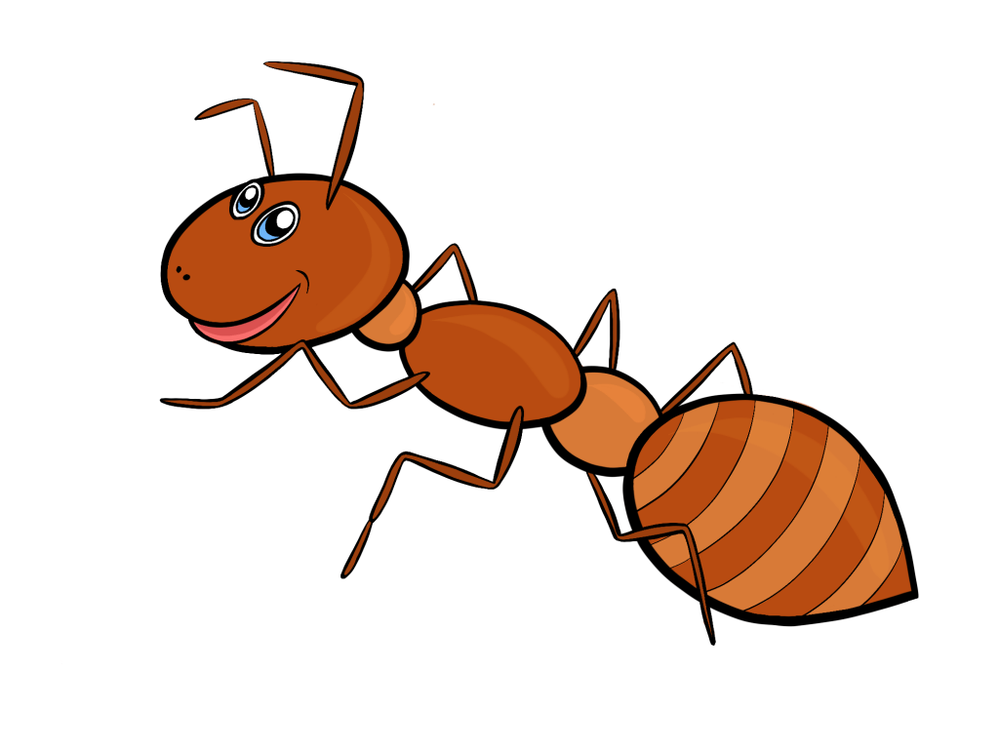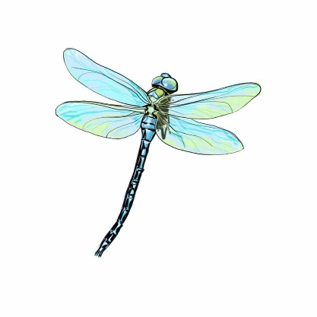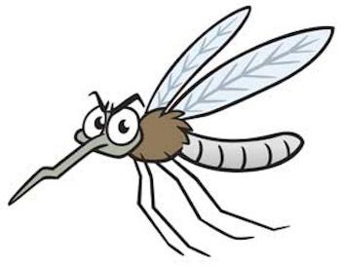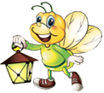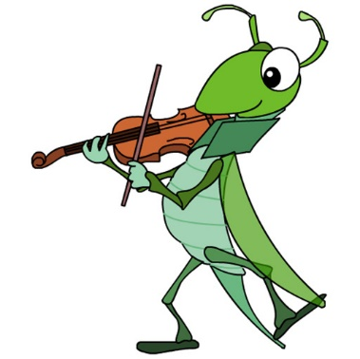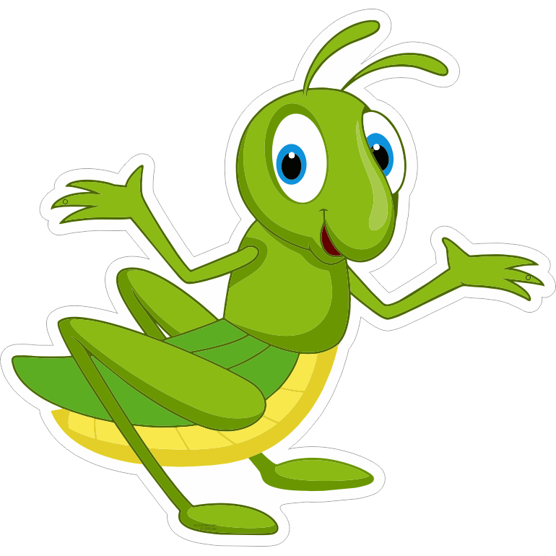

1

8

9

7

6

5

3

2

Ответы: 1. Кузнечик; 2. Бабочка; 3. Сверчок; 4. Светлячок; 5. Стрекоза;

6. Комар; 7. Муравей; 8. Осы; 9. Пчела.